

: 5 Types of sensor’s used in IoT

Internet of Things

XCSHA5

: B.Tech CSE

: 3rd yr A

X Jennifer Mary

**Gas Sensor**

**Definition**:

Gas sensors detect the presence and concentration of gases in the environment. Gas sensors are used for safety, environmental monitoring, and process control. These sensors can detect gases like carbon monoxide (CO), carbon dioxide (CO2), methane (CH4), and other hazardous substances.

**Working Principle**:

These sensors use chemical reactions to detect specific gases. For example, semiconductor-based sensors change their electrical resistance when they react with gases like carbon monoxide or methane.

**Applications**:

* Environmental monitoring (e.g., air quality monitoring)
* Industrial safety (e.g., detecting harmful gas leaks)
* Smart homes (e.g., gas leak detection)
* Automotive exhaust systems (e.g., emission control)

**Circuit diagram:**

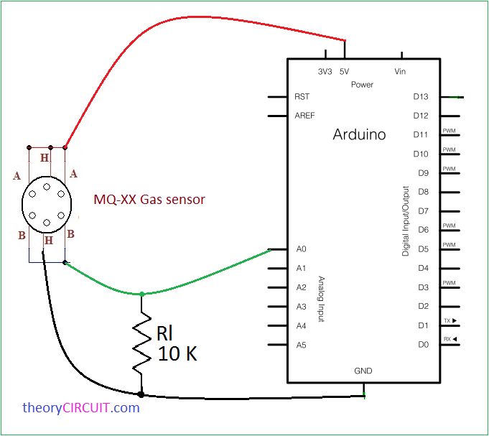

**Accelerometer**

**Definition**:

An accelerometer measures the acceleration or movement of an object in one or more directions. Accelerometers are essential in applications where detecting changes in motion, vibration, or orientation is required. They are highly useful in mobile devices and wearable technologies.

**Working Principle**:

Accelerometers work by detecting changes in capacitance or the deflection of a mass in response to motion, often using MEMS (Micro-Electro-Mechanical Systems) technology.

**Applications**:

* Fitness trackers (monitoring physical activity)
* Automotive systems (vehicle stability control)
* Smart phones and wearable devices (screen rotation, step counting)
* Industrial machinery monitoring (vibration detection)

**Circuit diagram:**

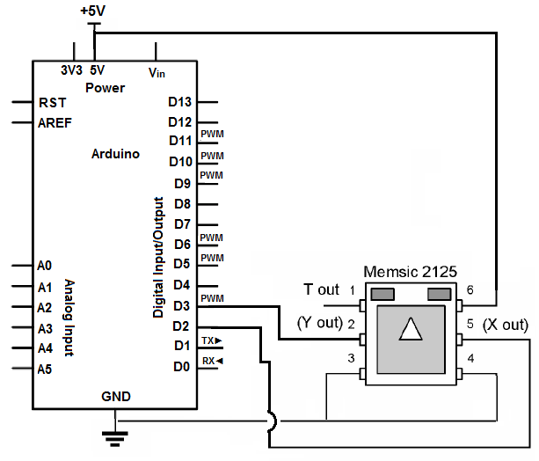

**Gyroscope**

**Definition**:

A gyroscope measures the rate of rotation or angular velocity of an object. Gyroscopes are key to providing orientation and rotational motion data, complementing accelerometers. They are widely used in navigation systems, such as those in drones or self-driving cars.

**Working Principle**:

Gyroscopes use the principle of conservation of angular momentum, detecting changes in rotational motion by measuring the resistance of a spinning mass or using MEMS technology.

**Applications**:

* Navigation systems (in cars, drones, and robots)
* Virtual reality (head tracking)
* Smartphone orientation
* Gaming systems (motion sensing)

**Circuit diagram:**

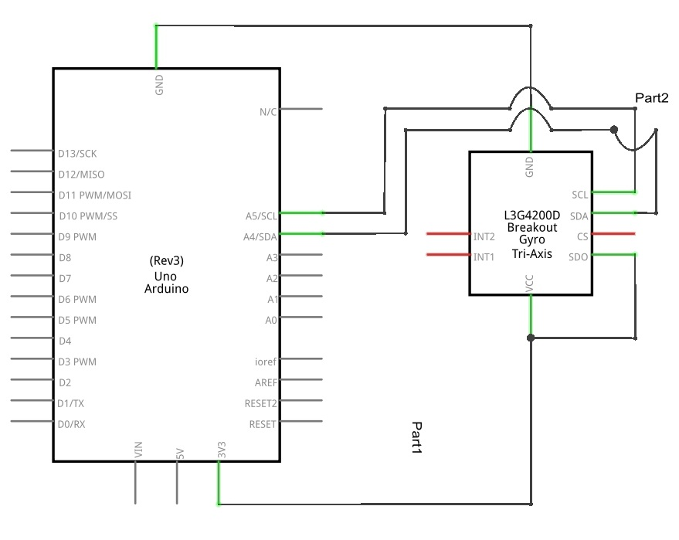

**Heart Rate Sensor**

**Definition**:

A heart rate sensor measures the number of heartbeats per minute. Heart rate sensors have seen increasing use in fitness trackers and wearable health monitors, offering continuous or on-demand monitoring. They can also be used in medical diagnostics and remote patient monitoring systems.

**Working Principle**:

Optical heart rate sensors use light-emitting diodes (LEDs) to shine light onto the skin, and photodetectors measure the amount of light reflected, which varies with blood flow.

**Applications**:

* Fitness trackers and smartwatches
* Health monitoring devices (e.g., for elderly care)
* Medical applications (e.g., hospital patient monitoring)
* Sports performance tracking

**Circuit diagram:**

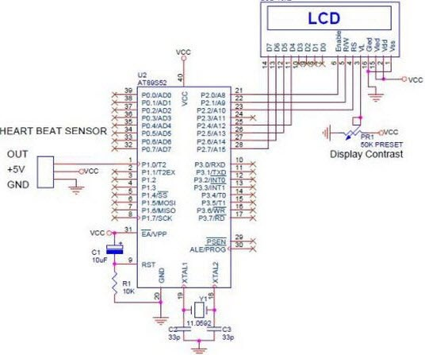

**Sound Sensor**

**Definition**:

A sound sensor detects sound waves and converts them into an electrical signal. Sound sensors enable devices to detect noise levels in an environment. They are used in applications where noise monitoring is critical for safety or performance.

**Working Principle**:

These sensors use microphones or piezoelectric elements that detect sound vibrations in the air. The sound waves cause the microphone diaphragm or piezoelectric material to move, which generates a corresponding electrical signal.

**Applications**:

* Smart home devices (voice assistants, noise detection)
* Industrial environments (machine noise monitoring)
* Automotive systems (vehicle sound detection)
* Surveillance systems (sound-based intrusion detection)

**Circuit diagram:**

